
IM Technical Specification Document

Revision History

Version | Date | Summary of Changes | Author
V1.0.0 | 3/19/2018 | First edition | Tony.yang
V1.0.1 | 4/19/2018 | V1.0.1 | Tony.yang

Technical Specification Sign-Off Signatory

_________________________  Prepared by Tony.yang  Designation: Application Architect |  | IT Department
_________________________  Reviewed by Xiaofei Wang  Designation: Deputy Technology Director |  | IT Department

Contents
1 Architecture Design 5
1.1 Design Philosophy 5
1.2 Technology Selection 5
1.3 Micro Service Unit and Dependencies 5
1.3.1 Services 6
1.3.2 Dependencies 6
1.4 UI Components 6
1.5 API Design 7
1.6 Publishing Event 10
1.7 Subscribing Event 11
2 Object Design 11
2.1 Conversation 11
2.2 Message 12
2.3 Contact 12
2.4 User 12
3 Database Design 13
3.1 Database Configuration 13
3.2 ER Diagram 13
4 Sequence Diagram Design 13
4.1 Message Online Push Diagram 13
4.2 Message Offline Save & Pull Diagram 14
4.3 User Online Diagram 15
4.4 Conversation Diagram 15
5 IM Components Details 15
5.1 IM Component Design 15
6 IM System Structure 17

Architecture Design

Design Philosophy
IM for better customer service in the business.

Technology Selection
Technology | Reason
reactJS+mobx | UI framework
sockJS | JavaScript library that provides a WebSocket-like object in the browser
springBoot | stand-alone, production-grade Spring based Applications
gradle | project build tool
docker | Micro-services container
redis | Cache data
elastic search | persistence message

Micro Service Unit and Dependencies

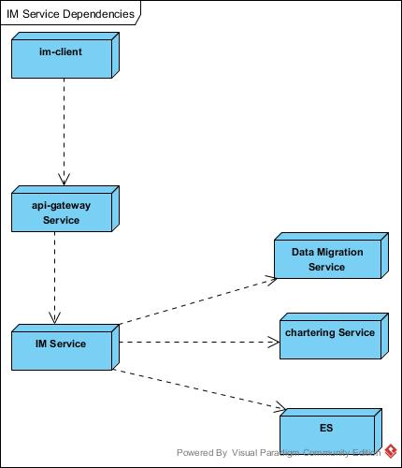

Services
Service | Description
IM-client | user chat tool by React UI Component
IM service | Provide contact ,messages,conversations management api

Dependencies
Dependency | Description
Api-gateway service | manage webscoket & inner services call
Data Migration Service | save&query user chat history messages
Chartering Service | Offer card informations manage

UI Components
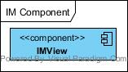

Components | Description
IMView | IM tools

API Design

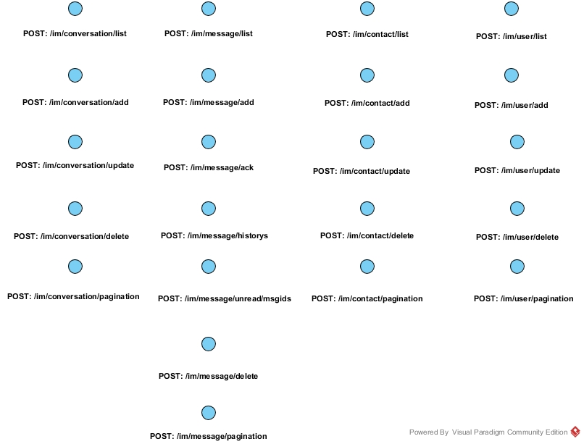

API | Input & Output
Conversation:
POST: /im/conversation/list | Input:  {  userId:[mandatory, long, length:1-18]  covsIds:[optional,Array<long>,nullable]  }  Successful Output:  {  result：[Array:Conversation,nullable]  }  Failed Output:  {  error: "xxx"  }
POST: /im/conversation/add | Input:  {  userid :[mandatory, long, length:1-18]  name :[optional, string, length:1-255]  userids:[mandatory,Array<long>,length:1-18]  }  Successful Output:  {  result:[object:Conversation,nullable]  }  Failed Output:  {  error: "xxx"  }
POST: /im/conversation/update | Input:  {  covsId: [mandatory,long,nullable]  userId :[mandatory, long, length:1-18]  name :[optional, string, length:1-255]  userIds:[optional,Array<long>, nullable]  }  Successful Output:  {  result:[object:Conversation,nullable]  }  Failed Output:  {  error: "xxx"  }
POST: /im/conversation/delete | Input:  {  userId :[mandatory, long, length:1-18]  covsIds:[mandatory,Array<long>, nullable]  }  Successful Output:  {  }  Failed Output:  {  error: "xxx"  }
POST: /im/conversation/pagination | Input:  {  start:[mandatory, int,],  pageSize:[mandatory, int,],  condition:{  name:[optional, string, length:1-255],  status:[optional, string, length:1]  }  }  Successful Output:  {  Result:[Array:Conversation,nullable]  }  Failed Output:  {  error: "xxx"  }
Message:
POST: /im/message/list | Input:  {  userId :[mandatory, long, length:1-18],  covsId: [mandatory,long,notnullable]  msgIds: [optional,Array<long>, nullable]  }  Successful Output:  {  result：[Array: Message,nullable]  }  Failed Output:  {  error: "xxx"  }
POST: /im/message/add | Input:  {  covsItems:[mandatory,Array<Conversation>,notNull]  }  Successful Output:  {  result: [Array: Message,nullable]  }  Failed Output:  {  error:"xxx"  }
POST: /im/message/ack | Input:  {  userId :[mandatory, long, length:1-18],  acks: [mandatory,  Array{  covsId: [mandatory,long,notnullable],  msgIds: [mandatory,Array<long>, nullable]  }, nullable]  }  Successful Output:  {  result: [Array: Message,nullable]  }  Failed Output:  {  error: "xxxx"  }
POST: /im/message/historys | Input:  {  userId :[mandatory, long, length:1-18],  covsIds:[mandatory,Array<long>, nullable]  }  Successful Output:  {  result:[Array: Message,nullable]  }  Failed Output:  {  error: "xxxx"  }
POST: /im/message/unread/msgids | Input:  {  userId :[mandatory, long, length:1-18],  covsIds:[mandatory,Array<long>, nullable]  }  Successful Output:  {  result:[Array: Message,nullable]  }  Failed Output:  {  error: "xxxx"  }
POST: /im/message/delete | Input:  {  userId : [mandatory, long, length:1-18],  covsIds: [mandatory,Array<long>, nullable],  msgIds : [optional,Array<long>, nullable]  ]  }  Successful Output:  {  }  Failed Output:  {  error: "xxxx"  }
POST: /im/message/pagination | Input:  {  start:[mandatory, int,],  pageSize:[mandatory, int,],  condition:{  userId:[mandatory,long,length:1-18],  covsId:[mandatory,long,nullable]  }  }  Successful Output:  {  Result:[Array: Message,nullable]  }  Failed Output:  {  error: "xxx"  }
Contact:
POST: /im/contact/list | Input:  {  userId: [mandatory, string, length:1-18],  contactIds:[optional, array<long>,nullable]  }  Successful Output:  {  result:[Array: Contact,nullable]  }  Failed Output:  {  error: "xxxx"  }
POST: /im/contact/add | Input:  {  userId: [mandatory, string, length:1-18],  contacts:[optional, array<Contact>,nullable]  }  Successful Output:  {  result:[Array: Contact,nullable]  }  Failed Output:  {  error: "xxxx"  }
POST: /im/contact/update | Input:  {  userId: [mandatory, string, length:1-18],  contacts:[optional, array<Contact>,nullable]  }  Successful Output:  {  result:[Array: Contact,nullable]  }  Failed Output:  {  error: "xxxx"  }
POST: /im/contact/delete | Input:  {  userId: [mandatory, string, length:1-18],  contactIds:[optional, array<long>,nullable]  }  Successful Output:  {  }  Failed Output:  {  error: "xxxx"  }
POST: /im/contact/pagination | Input:  {  start:[mandatory, int,],  pageSize:[mandatory, int,],  condition:{  userId:[mandatory,long,length:1-18],  name:[optional,long,nullable]  }  }  Successful Output:  {  result:[Array: Contact,nullable]  }  Failed Output:  {  error: "xxxx"  }
User:
POST: /im/user/list | Input:  {  userIds: [mandatory, Array<long>,NotNullable]  }  Successful Output:  {  result:[Array: User,nullable]  }  Failed Output:  {  error: "xxxx"  }
POST: /im/user/add | Input:  {  users: [mandatory, Array<User>,NotNullable]  }  Successful Output:  {  result:[ Array: User,nullable]  }  Failed Output:  {  error: "xxxx"  }
POST: /im/user/update | Input:  {  users: [mandatory, Array<User>,NotNullable]  }  Successful Output:  {  result:[ Array: User,nullable]  }  Failed Output:  {  error: "xxxx"  }
POST: /im/user/delete | Input:  {  userIds: [mandatory, Array<long>,NotNullable]  }  Successful Output:  {  }  Failed Output:  {  error: "xxxx"  }
POST: /im/user/pagination | Input:  {  start:[mandatory, int,notNullable],  pageSize:[mandatory, int,notNullable],  condition:{  userId:[mandatory,long,length:1-18],  name:[optional,String,nullable]  }  }  Successful Output:  {  result:[ Array: User,nullable]  }  Failed Output:  {  error: "xxxx"  }

Publishing Event

Event | Parameter

Subscribing Event

Event | Parameter

Object Design
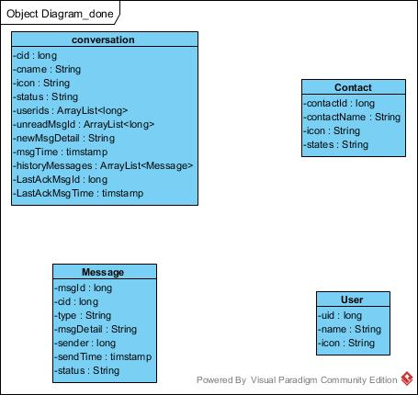

Conversation
Property | Data Type | Data Constraints
cid | long | Length :18
cname | String
icon | String
status | String
userIds | List<long>
unreadMsgids | List<long>
newMsg | String
newMsgTime | timestamp
historyMsgs | List<Message>
lastAckMsgId | long | Length :18
lastAckMsgTime | timstamp
createBy | long | Length :18
createTime | timstamp
updateBy | long | Length :18
updateTime | timstamp

Message
Property | Data Type | Data Constraints
msgid | long | Length :18
cid | long | Length :18
type | String
msgDetail | String
sender | long | Length :18
sendTime | timestamp
status | String

Contact
Property |  | Data Type | Data Constraints
uid | long |  | Length :18
contactId | long |  | Length :18
contactName | String
icon | String
states | String
createBy | long |  | Length :18
createTime | timstamp
updateBy | long |  | Length :18
updateTime | timstamp

User
Property |  | Data Type | Data Constraints
uid | long |  | Length :18
name | String
icon | String

Database Design

Database Configuration
Configuration | Value | Remark
Database Name | im
User Name | root
Password | root | For developer only
Default Charset | utf8mb4 | To support emoji
Dev DB Host | 192.168.48.89:23306
SIT DB Host
UAT DB Host
ID generator | Remote ID service

ER Diagram
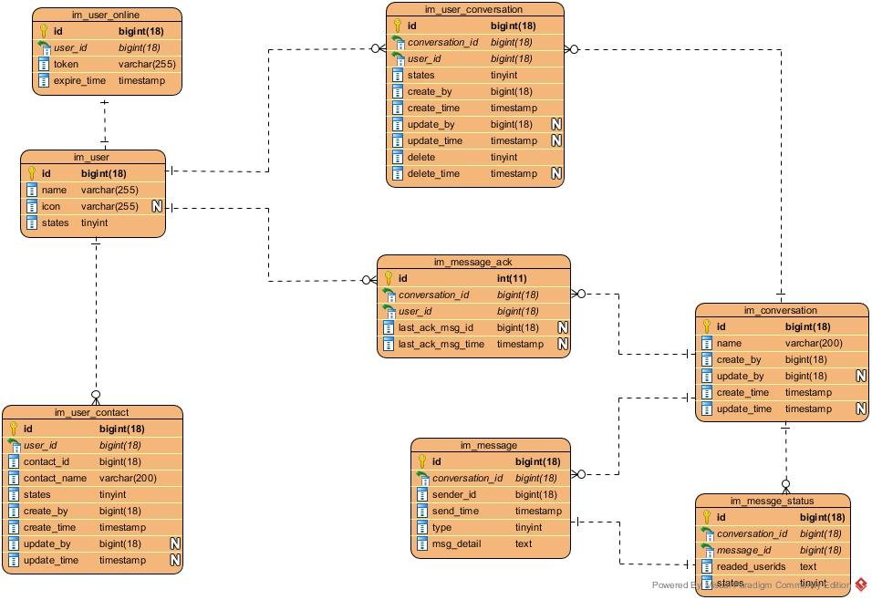

Sequence Diagram Design

Message Online Push Diagram
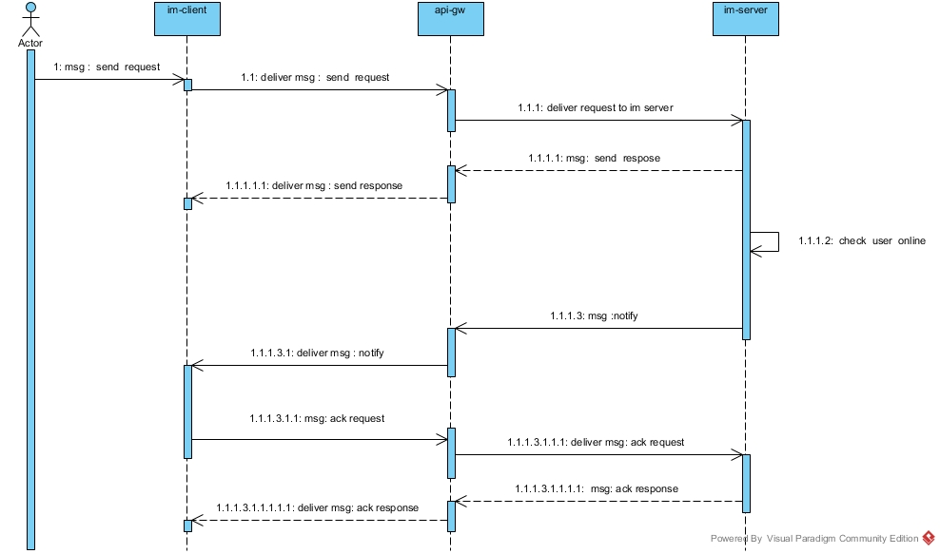

Message Offline Save & Pull Diagram
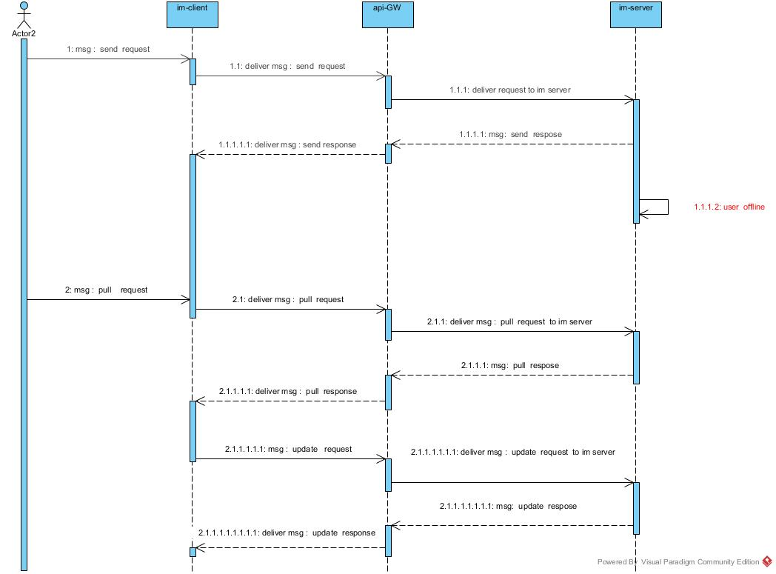

User Online Diagram
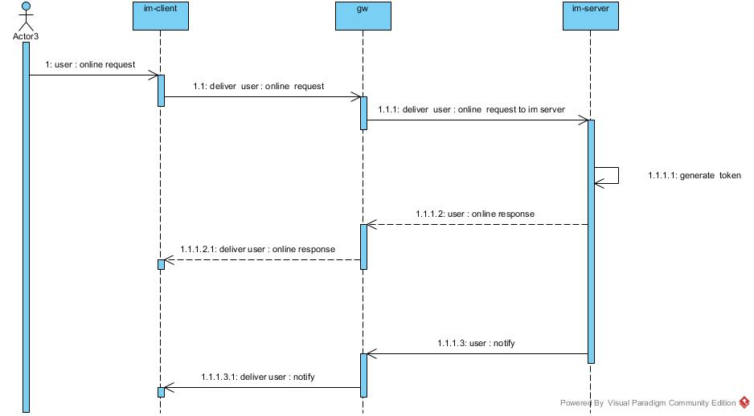

Conversation Diagram
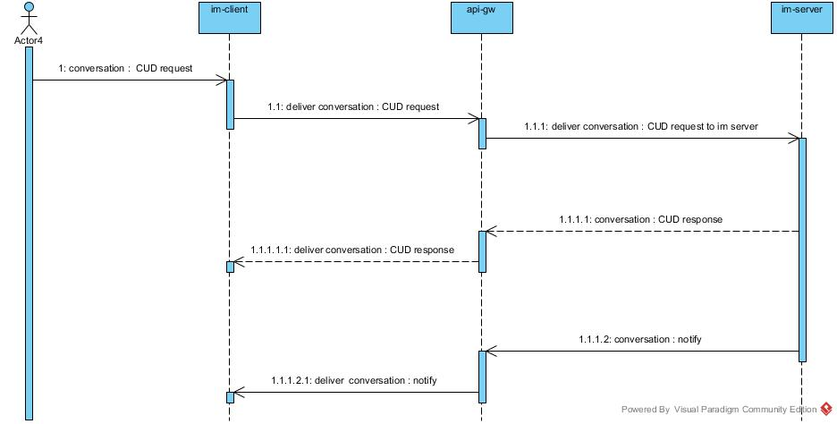

IM Components Details
IM components split details

IM Component Design
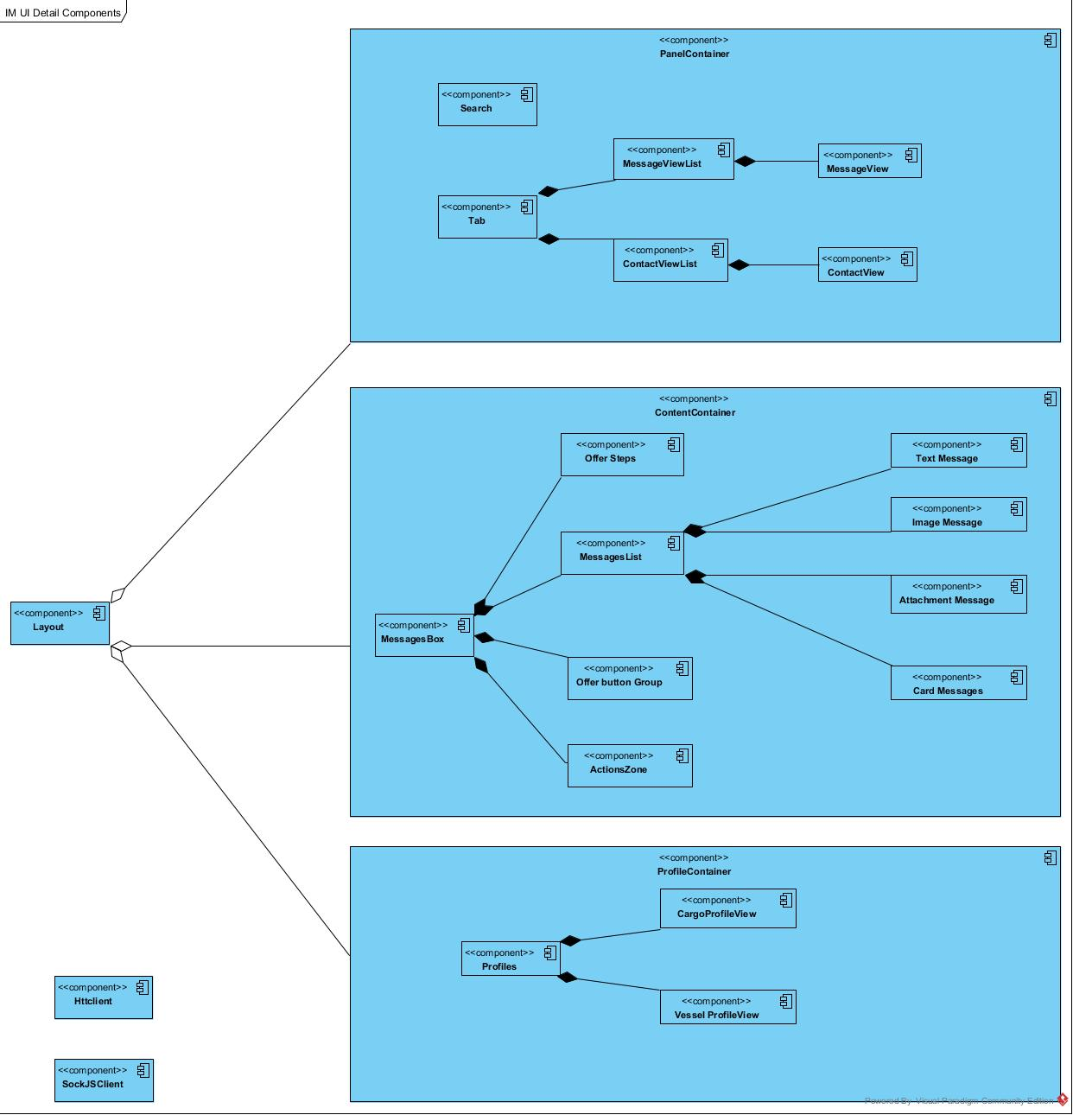

IM System Structure
